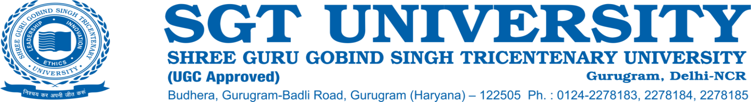

**7.1.9 Sensitization of students and employees of the institution to the constitutional obligations: values, rights, duties and responsibilities of citizens**

The SGT University takes pride in the fact that apart from preparing a sound academic foundation of the student community; the University constantly works upon to develop them as better citizens of the country. In this regard, SGT University, apart from imparting professional legal education, inculcates a feeling of oneness among the student community through various practices and programs. Various faculties have always been in the practice of organizing activities that not only initiate but also motivate the students to adopt various practices that promote the “Unity in Diversity” of our motherland. The University ensures that the students participate enthusiastically in all such activities. Since the last five years, the SGT University has strived forward with great effort to increase the level of awareness and appropriate practices amongst the students with regard to the following areas:

**1. National Identities and Symbols:** The University has always taken various direct and indirect steps which promote the awareness about various National Identities and Symbols. The Indian Tri-colour stands tall at the main entrance of the University and in this way the University spreads the message of Nation first policy. The main reception building of the University also houses the Tri-colour. The University celebrates the Independence Day & Republic Day with great pomp and vigour. The Faculty of Law organizes and celebrates the Constitution Day on an annual basis and thus contributes to the spreading of Constitutional values and ideals.

**2. Fundamental Duties and Rights of Indian Citizens:** The Faculty of Law, SGT University has organized various academic and co-curricular activities for the propagation of the Fundamental Duties and Rights of the Indian citizens. The students of SGT University have enthusiastically participated in various programs like:

1. Academic programs like Seminar, Conferences, Expert talks, etc which have enriched the awareness about these aspects.
2. Various activities like poster making competition, etc on related topics.
3. Organizing Annual SGT Moot Court Competitions on various contemporary legal issues.
4. Organizing various forms of legal aid and legal awareness camps to impart awareness of such issues.

**3. Constitutional Obligations:** The students of the University have participated in various activities like Supreme Court visits visit to the Rashtrapati Bhawan. All these visits have been organized to promote the awareness about various constitutional and legal obligations.

Further, apart from the above mentioned activities, the University has also organized student centric activities like paper, poster and essay competition displays at annual Synergy event etc. which have always received huge participation from the students and promoted their awareness about various aspects of Indian citizenship.