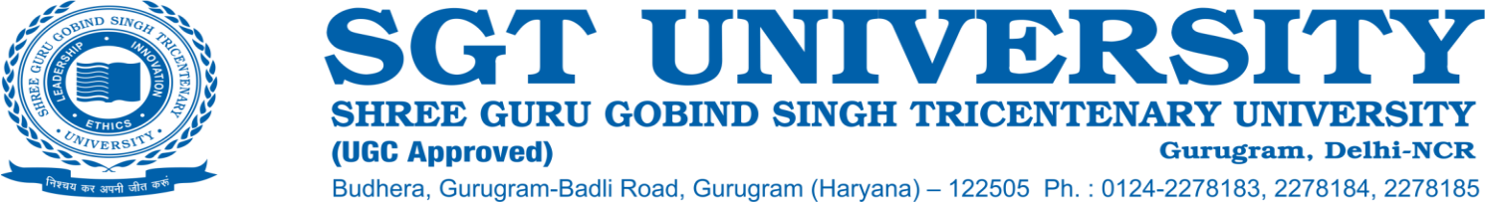

**7.1.8 Describe the institutional efforts/initiatives in providing an inclusive environment i.e., tolerance and harmony towards cultural, regional, linguistic, communal socioeconomic and other diversities (within 500 words)**

The SGT University is located at Chandu -Budhera on the outskirts of Gurugram which spreads over around 60 acres of lush green campus enveloped with serene beauty and environment. Students along with more than 3000 staff/faculty members come from various cultural backgrounds and carry forward their rich cultural diversities. The University takes extra efforts in providing an inclusive environment for all the students and employees. Tolerance and Harmony to cultural, regional, linguistic, communal, socioeconomic, and other diversities are best achieved by major events like Diwali Fest, Holi Fest, Symphonious at University levels and events like Esperanza, Aura, Impressions at the individual faculty levels.

Students have formed various clubs at the campus which also support and propagate the idea of diverse cultures. Diwali fest events have given opportunities to students from various state backgrounds like Haryana, North East states, Southern states, and all across India to showcase their rich dance forms, culture, and beliefs. Holi Fest, over the years has seen invitations to the traditional Lath Mar Holi where initially performers from Mathura were invited to showcase the whole story of Sri Krishna. Now, the students have started enacting the whole story through the colorful festival of Holi. The colorful Holi is celebrated with flowers on campus. These events have also seen fusion performances of all cultural dances and drama performances. Symphonious is an annual event where the University invites popular music singers like Malkit Singh, Mika Singh, Guru Randhawa and DJ Money with their teams to enthrall the students with rich cultural songs.

One key theme event on River Ganga was choreographed and performed by faculty members and students, which was performed at the prestigious Indira Gandhi Centre for Arts, New Delhi. This dance-based theatrical event showcased the rich culture and heritage of the river Ganga.

Regional events are also celebrated at the campus especially Lohri, Christmas, Dhanvantri Diwas, along with various state cultural events like Basant Panchami, Dahi-Handi, Teej, Ningol Chakouba (Translation: Married women invited for feast), etc. The University has also celebrated Hindi Diwas and state formation days like Haryana Day over the years wherein the rich culture of the state and country are highlighted through various debates, posters, and essay competitions of the students. This aspect of an inclusive environment is also achieved by the annual publication of the literary magazine “SGT Youth Pulse” wherein students are encouraged to pen down their own words, ideas, and images in the form of poems, stories, essays, and paintings. These are then compiled in the form of a magazine which is widely circulated. This magazine has been published on an annual basis since 2017. The University campus also houses a temple wherein many students worship their faith in God and festival ceremonies are also performed by students and faculty members equally. Socially connecting with rural people residing in and around the University campus is also encouraged respecting the cultural, communal, socioeconomic, and linguistic values of locals.