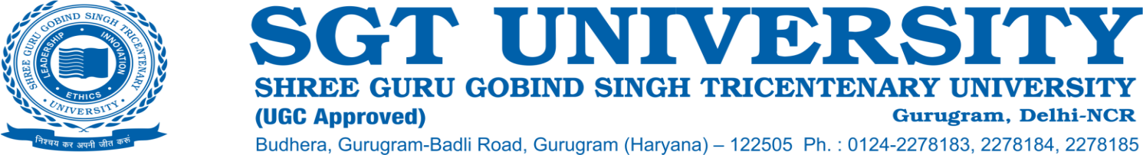

**7.1.3 Describe the facilities in the Institution for the management of the following types of degradable and non-degradable waste (within 500 words)**

* **Solid waste management**
* **Liquid waste management**
* **Biomedical waste management**
* **E-waste management**
* **Waste recycling system**
* **Hazardous chemicals and radioactive waste management**

**Response:**

The functioning of the SGT University exerts negligible stress on environment due to consciousness of environmental impacts from anthropogenic activities which are imparted to the students and staff periodically. There are number of practices involved to reduce the generation of wastes as much as possible. The health-related faculties have courses and topics dedicated to biomedical and radiological waste and their proper management and disposal to reduce the environmental impact due to medical and hospital waste. Courses are also taught regarding the safe use of drugs, their dosage and administration.

**1. Solid waste management:** Solid waste is produced through activities carried out routinely during the university processes including paper, plastics, glass, metals, food residue and packaging materials etc. The waste is collected and segregated properly at each level and source. The administrative supervisor in each block oversees that the waste at each floor is collected at given time intervals. The cleaning personnel at each floor collects the solid waste, segregate it and gather the solid waste in separate dustbins based on the recyclability and biodegradability of the waste. The University has installed a kitchen waste disposal unit which is electrically powered.

**2. Liquid waste management:** Liquid wastes generated by the University are:

1. Sewage Waste
2. Mess and Cafeteria Waste
3. Laundry Waste

The liquid waste is treated through wastewater treatment plant and is used for gardening and horticultural activities. The University has also setup its own STP and ETP unit to treat sewage waste before discharging in water bodies.

**3. Bio-Medical waste management:** Biomedical waste from University Hospital and Dental Hospital are collected in separate bins. The University has engaged with an authorized bio-medical waste management contractor who collects the waste from the designated place and disposes it according to bio-medical waste management rules.

**4. E-waste management:** Electronic circuits, memory chips, motherboards, compact discs, cartridges etc generated by electronic equipment such as Computers, TV, Phones, Printers, Fax and photocopy machines are reused and recycled properly. An exchange or buyback system is adopted instead of direct disposal while buying a new product. The e-waste generated from hardware products which cannot be reused or recycled is being disposed centrally through government authorized vendors.

**5. Waste recycling system:** Waste recycling plants namely Sewage Treatment Plants (STPs) and Effluent Treatment Plants (ETPs) system are present in the campus for liquid waste water recycling:

Number of Sewage Treatment Plants: 01

Number of Effluent Treatment Plant: 01

**6. Hazardous chemicals and radioactive waste management:** Standard Operating Procedure is followed for the hazardous chemicals and radioactive waste disposal. Records are maintained for the compliance of AERB norms.