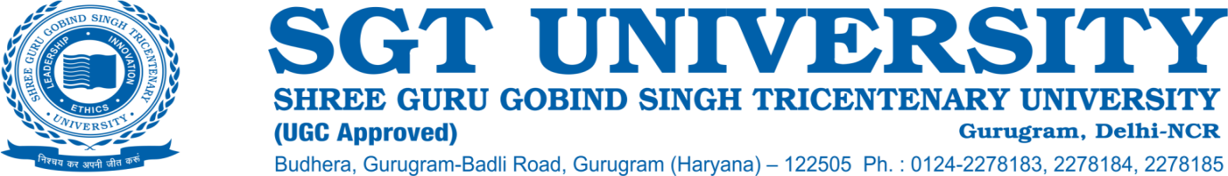

**6.3.1 The institution has effective welfare measures for teaching and non-teaching staff, and other beneficiaries.**

**Response:**

The following facilities as Welfare measures are provided to all permanent teaching and non- teaching employees by SGT University, which help in maintaining healthcare, morale, safety and satisfaction:

1. Facilities and services of SGT Medical Hospital with state of art facilities alongwith 30% concession on the investigations and treatment charges for SGT staff and their family members.

2. Services of Dental Hospital with advanced facilities and free simple treatment procedures and 20% discounts on complex treatments for SGT staff members and their family members.

3. Maternity benefits for female employees of the University.

4. Leaves to teaching and non teaching staff including casual, earned sick and academic leaves.

5. 24 hour power back-up support are available to all the employees.

6. Wi-Fi facility throughout the campus.

7. The faculty members have dedicated cabins & workstations wherein they can perform their duties effectively.

8. Crèche facility for the children of the teaching and non-teaching employees.

9. Subsidized Cafeterias and Mess facility for staff members.

10. Transport facility including buses with nominal charges.

11. Bank facility.

12. Shopping complex.

13. Festival advance

14. Residential Quarters are provided on campus for teaching and non-teaching staff.

15. All Faculties members are encouraged to get enrolled for Ph.D. program with 50% concession on Ph.D fees for in-house faculty and staff.

16. Concession on the fees of the wards of staff members to the term of 35%.

17. Faculty incentives for effective contribution in academics, research and for University development.

18. Travel grant to Faculty members to attend national and international conferences

19. Incentives for publications in high impact journals and other incentives to Faculty members for research promotion as attached.

20. Well defined appraisal and promotion policy

21. Extracurricular activities for Faculty members are organized every year to break the monotony like Fun Games, Diwali fest, Holi fest and sports activities for Faculty members and non-teaching staff.