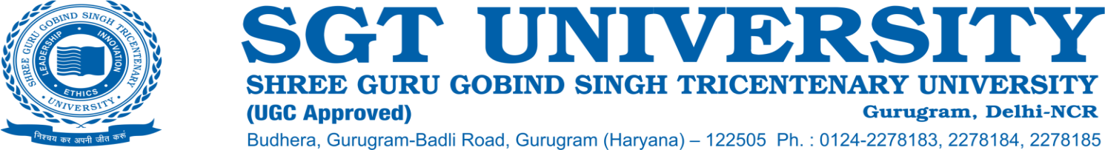

**6.1.1 The Institution has clearly stated vision and mission which are reflected in its academic and administrative governance.**

**Response:**

Under the parasol of Dashmesh Educational Charitable Trust(1999), the seeds of SGT were planted as SGT Dental College, Hospital and Research Institute in 2002. With the continuous at present SGT University is running 176 programs across 18 faculties and focused development, SGT University came into existence on 24th January 2013 by the Haryana Private Universities (Amendment) Act No. 8 of 2013. The Governance of SGT University sets an example of true leadership as it strives to develop excellence and leadership qualities among all its students and teachers.

**Vision:**

“To nurture individual’s excellence through value based, cross-cultural, integrated and holistic education adopting the contemporary and advanced means blended with ethical values to contribute in building a peaceful and sustainable global civilization”.

**Mission:**

* To impart higher education at par with global standards that meets the changing needs of the society
* To provide access to quality education and to improve quality of life, both at individual and community levels with advancing knowledge in all fields through innovations and ethical research.
* To actively engage with and promote growth and welfare of, the surrounding community through suitable extension and outreach activities
* To develop socially responsible citizens, fostering ethical values and compassion through participation in community engagement, extension and promotion activities.
* To create competitive and coordinated environment wherein the individual develop skills and a lifelong learning attitude to excel in their endeavours.
* To develop Centers of Excellence culminating in achieving the cutting-edge technology in all fields.

The University strives to nurture excellence in each individual whether student or faculty.

Imparting quality education to the students who are the ambassadors of the University, by regularly updating the curricula benchmarked against global standards, exposure to the best of academic experts to encourage innovation and interdisciplinary research coupled with the involvement and participation of the students in cultural and extracurricular activities and community outreach activities give a life like experience to the students and instills the leadership qualities in them.

The governance of the Institution is not only student centric but equal emphasis is given on the faculty members, the stakeholders. The wisdom and experience of the eminent personalities serving the University authorities supports the faculty members to develop and enhance their individual capacities and excel in their disciplines as well as to create Centers of excellence.

Awarding the contributions of the faculty members in the University, academics and research is an example of Governance nurturing excellence in the faculty members and to develop future leaders for the organization.

The Governance of SGT University is participative with involvement of teachers, HODs and Deans in all committees and decision making bodies of the University.

University has following centers of excellence:

1. National Resource Simulation Centre

2. Central Synthetic Chemistry Lab

3. Centre of Science Popularization and Cosmology

4. Atal Community Incubation Centre

5. Centre of Excellence in Pedagogy