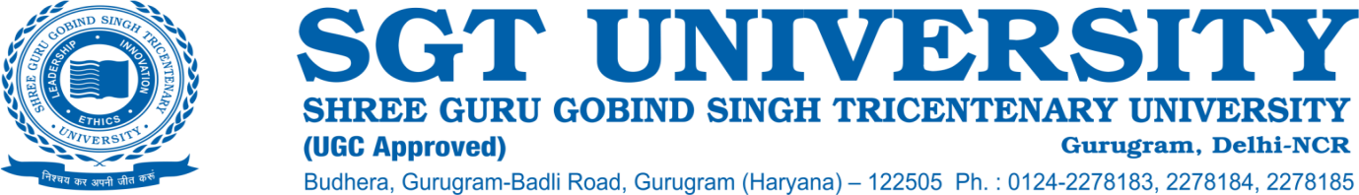

**5.1.4 The institution has an active international student cell of the preceding academic year.**

**Response:**

SGT University has established an Office of External Affairs in which an International Relations Team collaborates with foreign universities/organizations and participates in various international exhibitions and educational fairs. This department works actively to promote student and faculty exchange programs and also works to cater to the specific needs of International students. The University has successfully completed faculty and student exchange programs at the International and National levels. The University strives hard to make its students truly global citizens. One of the ways to achieve this is to welcome international students for courses as well as exchange programs. The international relations team at SGT University is dedicated to managing incoming and outgoing short-term student and staff mobility. The campus is well equipped in terms of manpower and logistics to manage batches of up to 30 students at a time.

In line with NEP 2020, the Office of External Affairs assists foreign students in eligibility assessment, admission, obtaining Study/ Research Visa and residential permit. The office also disseminates information on study abroad opportunities and avenues for academic collaborations to faculty and students of various University Departments. The Office functions as a liaison between the foreign students, Academic Institutions, Faculty, University Offices, Diplomatic Missions, State/ Central Government Departments, and other agencies.

The International relations team supports the students and organizes activities for them including the Organization of Reception and Orientation Programmes for international students. Helping the students in the process of registration, visa extensions, and other academic and non-academic related issues. The team acts as a contact point for international students for appropriate information and assists in ensuring safety, security, discipline, well-being and grievance redressal of the international students.

Celebration of cultural activities, International festivals, conduction of cross cultural programmes, international lecture series and liaisons with respective embassies to ensure that International students participate in important embassy functions.

The international relations team also provides the necessary expertise in advising of various aspects of settling in on campus and compliance with immigration requirements for all international students, international faculty and staff, and short-term exchange visitors. Similar assistance is also extended to SGT students aspiring to travel overseas to facilitate a safe and pleasant experience.

The University endeavours to provide all support services to ensure that the issues of all the students are addressed in a timely manner. In the September 2019 University welcomed the first batch of 20 students from Binawan Institute of Health Sciences, Jakarta. The students had a week long programme with multiple lectures, live workshops and interactive sessions organized by Faculty of Physiotherapy and Faculty of Indian Medical System.