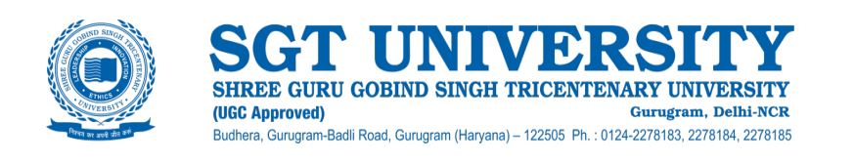

**4.3.1 Response:**

The SGT University makes every effort to provide an Integrated Knowledge Resource by maintaining state-of-the-art and duly updated various departmental libraries, with all the required academic resources including 24 x 7 internet facility and electronic gateways for accessing and sharing electronic learning and teaching resources among researchers, teachers, students and the visitors. Access of e-journals, databases and library information etc. is provided through SGT University OPAC portal or Internet gateway with an internet speed of **2.5** GBPS. All e-resources are accessible locally within the campus as well as remotely through ID & password.

The SGT University library is automated using the integrated library management system software Koha. Koha is an open sources Integrated Library System (ILS) it is used worldwide by libraries for the automation of libraries. Koha is a web-based ILS, with a [SQL](https://en.wikipedia.org/wiki/SQL) database ([MariaDB](https://en.wikipedia.org/wiki/MariaDB) or [MySQL](https://en.wikipedia.org/wiki/MySQL) preferred) back end with cataloging data stored in [MARC](https://en.wikipedia.org/wiki/MARC_standards) and accessible via [Z39.50](https://en.wikipedia.org/wiki/Z39.50). The [user interface](https://en.wikipedia.org/wiki/User_interface) is very configurable and adaptable; Koha has most of the features that are very helpful in the automation of the library. The library is automated with ILMS-Koha, and the library is currently using KohaVersion: 20.05.07.000.

**Library ILMS: Koha**

**Library Automation year: 2015**

**KohaVersion: 20.05.07.000.**

The SGT University has provided remote access to its users through the KOHA-Library System, a product of a web-based interface that is compatible with mobile devices. Online Central Library System provides authorized access to subscribed e-content through a single interface login. The users can directly access the library with help of the web OPAC service, through which the users can search the collection of library resources- books, journals periodicals, CD’s theses and dissertations and online resources of the library. Users can log in into the account of KOHA (ILMS) web OPAC service and can check the library catalog information, patron profile information, and reading history and can provide feedback and suggestion to the library. LMS-Koha is very useful in saving time for library members as well as library staff. The institutional library also has a Shodhganga membership that facilitates the inclusion of doctoral research theses in the National depository after plagiarism check by the appropriate software through IQAC and ensures the development of quality and original research in the university. With the motive to enhance the educational opportunities to benefit people all over the world SGT University has developed its e-content on the institutional LMS **E-Learning SGTU** a channel on YouTube and a webpage **- elearning.sgtuniversity.ac.in**. SGTU also provides digital Library online sources remotely to all the users through **sgtuniversity.knimbus.com.**