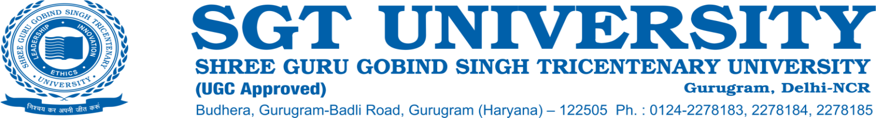

**2.3.1 Student-centric methods, such as experiential learning, participative learning and problem-solving methodologies are used for enhancing learning experiences**

**Response:**

Students, at SGT University, are considered the most significant stakeholders and keeping this into consideration, the university aspires to design the entire academic process, including curriculum’s planning, delivery and evaluation.

Internal Quality Assurance Cell (IQAC) of the SGT University has also taken the initiatives in this direction to improvise the pedagogic techniques followed by each faculty for their respective courses and programs. Student-centered methods have been implemented throughout the University through faculty training via a series of demonstrations and Faculty Development programmes (FDPs).

Various methodologies that have been adopted to make the learning session interactive and maintain the interest of the students throughout the learning session.

1. Student’s Interactive Session (SIS)

2. Student’s Seminar(SS)

3. Teacher’s Seminar

4. Project Based Learning (PBL)

5. Problem-Based Learning (PBL)

6. Case Studies

7. Integrated Teaching

8. Focus Group Discussion

9. Spot Group Discussion

10. Presentation cum Panel discussion

12. Fish Bowl Technique

13. Role Play

14. Simulation Technique

15. Tutorials

**ICT Enabled Teaching**-

The constant up-gradation of the ICT for the use of innovative pedagogic techniques has been the thrust area of the University. Well-equipped classrooms with smart boards, Language Labs, E-Learning resources, Webinar sessions, Video competencies, Online references, motivational talks, educational videos, and web references are also used by faculty to support the teaching-learning process. Faculty members are also encouraged to innovate and devise their own methods of teaching that involve the participation of students.

For **Simulation Training and hands-on training** of the students and faculty members, the National Simulation Reference Centre is set up through the consortium of the Indian Nursing Council (INC), Jhpiego, Laerdal Medical India and SGT University. Another simulation center is in pipeline to cater and support the needs of the students. Various simulation training to the students of medical and non-medical students and faculty members are provided through the mode of practical learning in their skilled labs. The consortium is quality and innovation-focused and research-driven in pursuit of an individual with experience in health science education; motivated to innovate, create, and prosper both nursing and inter-professional initiatives that support the NRSC. Projects, Internships, and Industrial visits also form part of a regular feature for practical and hands-on experiential learning for non-medical domain students.

To give the experience of **Blended learning** and to engage the students in activities during class hours, the University is also developing its online learning content through the creation of an Institutional e-learning portal https://elearning.sgtuniversity.ac.in. This makes the learning content easily accessible to the students anytime, anywhere. The Objectively Structured Clinical Examination (**OSCE**) and Objectively Structured Practical Examination (**OSPE**) in medical-related programs have been introduced mainly for formative assessments and many programs are regularly organized to train the faculty members in the same.